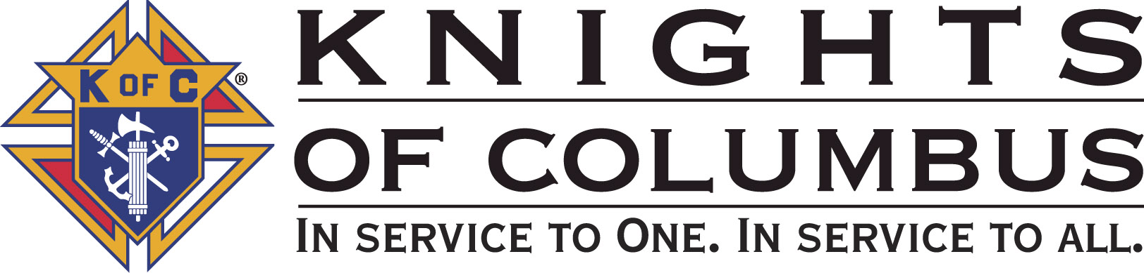

Council #13672 at Divine Savior Fr. Neil W. Seidl
Orangevale, CA
February 2011 Volume 9, #8

Monthly Grand Knight’s Message

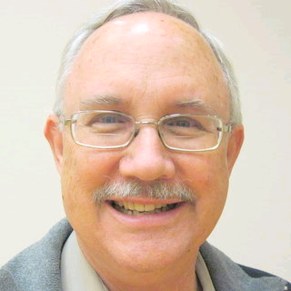
Dear Brother Knights,
Grand Knight Bruce Pyle

Dep. Grand Knight Tony Aiello

Fin. Secretary Micheal Wagner

Treasurer Allen Brown

Chancellor Jack Hill

Warden Bob Reilly

Advocate Dave Brodie

Recorder Ray Coughlin

Trustee 1st Yr Charlie McDermott

Trustee 2nd Year Joe Luchi

Trustee 3rd Year Mike Duskus

Inside Guard Douglas Copley

Outside Guard John Carvalho

Chaplain Fr. Roman Mueller

Lecturer Sam Cimino

Field Agent Tony Magdaleno

The Knights of Columbus Council #13672 at Divine Savior Fr. Neil W. Seidl Chapter meets Monthly on the First Tuesday of each month at 7:00 p.m.
Please join us to help our Catholic Community.
For insurance needs, please contact our Field Agent Tony Magdaleno at 470-9205 or by mail at
P.O. Box 2737
Rancho Cordova, CA 95741

Happy New Year to all! The second half of our Columbian year is off to a great start.

January saw the church décor return to normal (ordinary time). Our Free Throw event resulted in some of our students moving to the next level. Thanks to a record number of helpers, including five new brothers, we held our first 2011 pancake breakfast and blood drive with excellent results. We participated in the Walk for Life in San Francisco. And, by the time this is published, we’ll have conducted another Recycle event. We’ll hear the full reports on these and upcoming events at our regular meeting on February 1st (7 pm, Parish Hall).

Tom Hogan, Mike Wagner and I attended the NorCal Chapter meeting in Vacaville along with our Golf Chairman, Mike Subbotin, who presented information on our golf fundraiser and challenged all the other councils to compete for an annual trophy and bragging rights.

Looking ahead… Knights from all over the state will be attending the “Knights at the Kings” game on February 4th. A highlight will be the singing of the National Anthem by one of our own council brothers. Uncertainty about the Kings and the arena might be additional reasons to attend.

I’m excited to report that, under the guidance of Dennis Harrington and our web developer, the launch of our Council website is imminent. Jack Hill is working on the annual fireworks sale. Our nomination committee has been formulated with Bob Reilly and Dave Brodie once again agreeing to serve and asking you to let them know of your desires.

With plenty of things to do this year, I hope at least one of your New Years resolutions to is become more involved in the council. Check out the attached calendar of events. Only through our committed involvement can we maximize our effectiveness in the community, the parish and the church.


Fraternally yours,

Bruce Pyle, Grand Knight

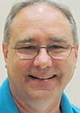
Treasurer Report
(Presented by Allen Brown)

KOC Council No. 132672 – Date balanced: 1/4/2011

Business: $11,015.19
CD 50 - 52: $3,249.79
Charity: ($19.10)
Total: $14,245.88

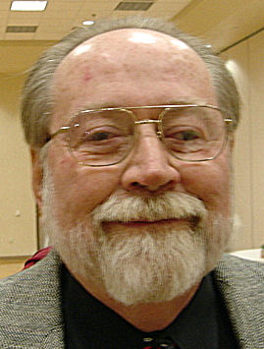

Financial Secretary’s Corner
(Presented by Michael Wagner)

Batch 72 $276.20
Dues $222.00
365 Club Dues $54.20
Batch 73 $423.45 (Charity Account)
Charity Account Funding $423.45
Batch 74 $608.80
Dues $555.00
365 Club Dues $54.80
Batch 75 $45.00
ID Drive $45.00
Batch 76 $13.17 (Supreme Account)
Dues Adjustment $13.17

Batch 77 $1010.00 (Charity Account)
Charity Account Funding $1000.00
Donation $10.00
Batch 78 $1125.90
Dues $952.00
365 Club Dues $121.90
Raffle Proceeds $52.00
Batch 79 $388.75
Dues $185.00
365 Club Dues $16.95
Pancake Breakfast $186.80
Batch 80 $679.00
Pancake Breakfast $679.00
Grand Total $4571.27


2011 Dues
Many of you have paid you 2011 dues and received your new 2011 membership cards, thank you. For those who have not paid yet, your second notice is in the mail; please pay your dues now. If there is a financial hardship, please call DGK Tony Aiello at 933-4029.

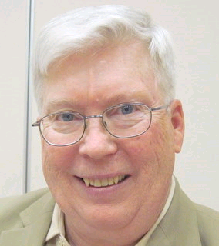

Recorder’s Motions
(Presented by Ray Coughlin)

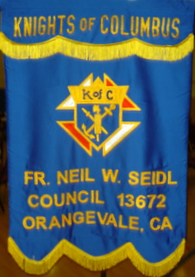
As a result of the general membership meeting on January 4th, 2011, the following motions were introduced, seconded, and passed by the general membership present:

- That the Council advance Doug Copley $350.00 to purchase food and supplies for the Pancake Breakfast on January 16th, 2011. This is a budgeted item. Maker: Doug Copley; seconded by: SK Ray Coughlin. Type of Funds: General,
- 2) That the Council plan and host a Golf Tournament at Catta Verdera Country Club in Lincoln on May 23rd, 2011, and approve the payment of a deposit of up to $1,000.00. Specific charities will be selected and announced later. This is a budgeted item and does not need to be published. Maker: Michael Subbotin; seconded by: Thomas Hogan. Type of Funds: General, and
- 3) All monthly bills presented to the Trustees who recommended that they be paid.

Knight of the Month
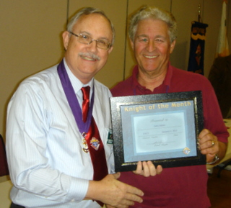
(Presented by Bruce Pyle)

Sam Cimino joined our council last March, took his 2nd and 3rd degrees in June, and shortly thereafter, accepted the position of Lecturer. Sam quickly demonstrated a desire to be involved and a devotion to help wherever he can. This is manifest in his participation in such events as the pancake breakfast. As Lecturer, his humorous and inspirational monologues have added a welcome dimension to our meetings.

Family of the Month

(Presented by Bruce Pyle)

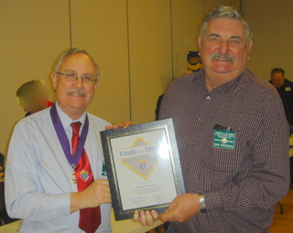
Few couples are as involved in our council and our parish as Dan and Deanna Freeman. A PGK and currently our Council’s Church Activities Director, Dan always take a lead role in our ID drive, Octoberfest, and strategic planning; and has participated in just about every other opportunity that is available. He is a past member of the church council and has been Environment Chairperson (Church decorations) for many hears. Deanna is a regular assisting in the parish office and is active in the St. Vincent de Paul ministry having recently stepped down as treasurer after over 5 years of service. Together, they worked the Treasurefest, participated in our Posada celebration and are regulars at council and parish activities.

Help Name Our Newsletter!

Our Knights of Columbus Monthly Newsletter is in need of a name and we are looking for your help. Forward Newsletter name ideas as soon as possible and your name may be the one that wins! The Newsletter Committee will review the entries and announce the winner next month.

Please send your name ideas to Dennis Harrington (dharring2000@gmail.com).

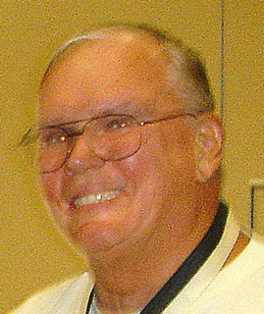

Let the Sunshine
(Presented by Jack Hill)

Cards are available to be sent out to members and families in need. For future need, please remember to contact Jack Hill with any sunshine activity or prayer cards that need to be sent.

You can contact Jack at 916-989-2106 or jack014@aol.com.

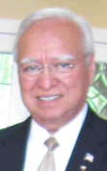
District Insurance News
(Presented by Tony Magdaleno)

KNIGHTS OF COLUMBUS INSURANCE
“YOUR SHIELD FOR LIFE”



Beneficiaries… Your Loved Ones

Valentine’s Day will soon be here! Do you know who the beneficiary is on your life insurance policy? Sometimes it is easy to overlook the simplest of things.
Why is it so important to know and to have your beneficiary information updated? A life insurance policy protects the financial status of Your Loved Ones – in the event of your death.
When Purchasing your Knights of Columbus insurance policy, you selected a primary beneficiary, and if you desire, a contingent, or secondary beneficiary. It’s always a wise choice to have a contingent beneficiary because you may outlive your primary beneficiary. A contingent beneficiary is the person designated to receive life insurance policy proceeds if the primary beneficiary dies.
By being specific as possible in the wording your beneficiary designation you make sure that the life insurance proceeds will be available to your wife, daughter, son, etc., in a timely manner when needed most.
Your life situation will undoubtedly change over time. Plan to update your beneficiary designations periodically. This will ensure that your life insurance coverage will protect those you love and want to protect.
Changing your beneficiary is fairly simple. I can provide you with the necessary forms, and can help you fill them out. I can also help you with all of your life insurance policy beneficiary designations for any life insurance policy you hold - regardless of the company that issued it.
To contact me with regards to any of your insurance needs, please call me at (916) 470-9205 or e-mail me at tony.magdaleno@kofc.org

Fraternally, Your Brother and Field Agent,

Tony Magdaleno
Field Agent #14661 CA Lic. # OG27147

Committee Report - Membership
(Presented by Ray Coughlin)

If you know of someone who would like to join our council, please refer them to Ray Coughlin at (916) 989-4226 or Tony Magdaleno at (916) 470-9205.

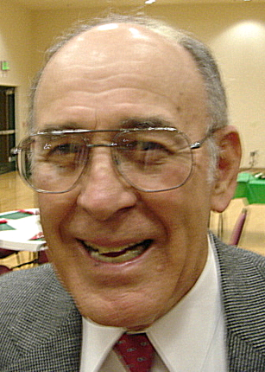

Committee Report - Family
(Presented by Guy Sanchez)
Please contact Guy Sanchez at (916) 965-3834 with Family Service Program questions.
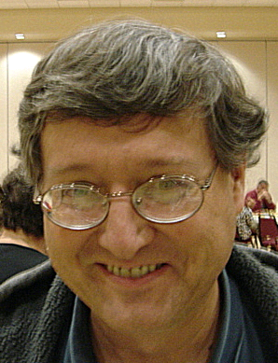

Committee Report - Youth
(Presented by Bill Manos)

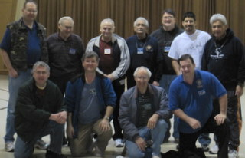
The basketball shootout took place on 1/9/2011 at St. John the Baptist
Church in Folsom.
The 3 youth that placed to go on to the district level on February 12,
2011 at Community Center at Holy Family Church at 7817 Old Auburn
Road– Citrus Heights, CA are:
Robert Manos, age 14
Amanda Loya, age 12
Marcus Manos, age 11
Special thanks to Vinnie Papa and Patrick Paulitz for volunteering to help.
Please contact Bill Manos at (916) 965-3834 with Youth Service Programs questions.

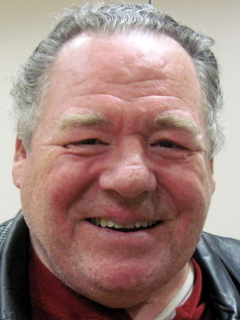
Committee Report – Council
(Presented by Bill Windle)

Pancake Breakfast Update
All is well with Council and a huge thanks to Doug Copley and his large crew of merry men who did a great job (one of our best) on the pancake breakfast and blood drive on January 16, 2011. I look forward to seeing you all at the next pancake breakfast and blood drive in May. Thanks again; job well done.
Special Thanks to All the Pancake Breakfast Volunteers!

Allen Brown
Alvin Baughman
Andy Ventimiglia
Bill Biasley
Bill Manos
Bill Wagner
Bill Windle
Bob Peterson
Bob Reilly
Charley Novello
Dan Freeman
Dave Brodie
Don Rose
Doug Copley
Ed Barbero
Ed Feldmann
Guy Sanchez
Jim Bennett
Joe Luchi
John Carvalho
John Fontana
John Okaru
Matt Peterson
Mike Wagner
Pete Trujillo
Ray Coughlin
Rich Dean
Sam Cimino
Tom Hogan
Tom Sekel

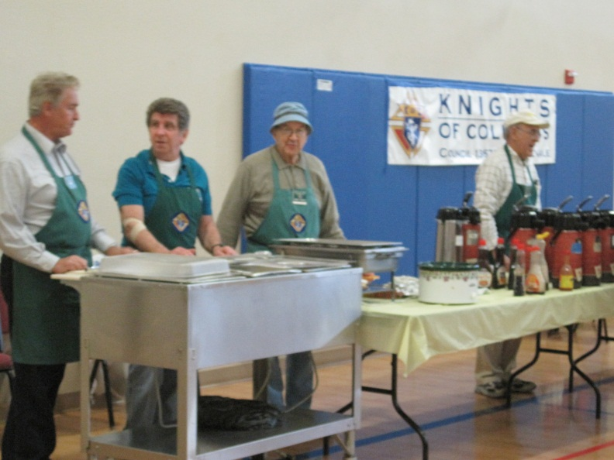
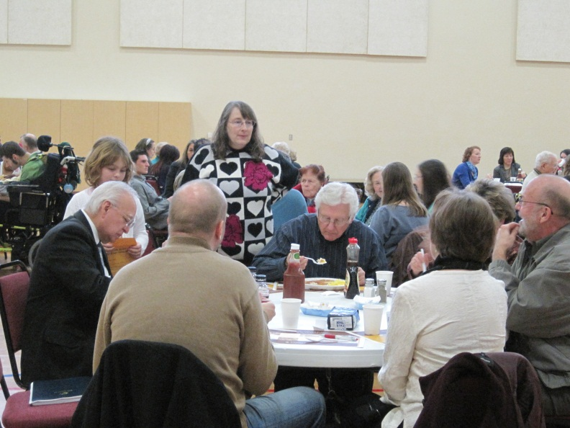
Lots of Fun and Food at the Pancake Breakfast!

Recycle Day Update!
The recycle event January 29, 2011 was a smashing success! BEST EVER; WE TOOK IN 91 BOXES TO SHRED. Last record was 40 boxes. WE ALSO FILLED TWO TRUCKS FULL OF E-WASTE; again most ever last events we have filled one truck.
Many thanks to Chairman Matt Peterson and his Co-Chairman Bob Peterson for a job very well done. Thank you to Tom Hogan for getting the word out about this event and Doug Copley and Don Marnach for providing the lunch and beverages. Thanks to Bill Amantea for painting the wonderful signs which brought the public in and last but not least thanks to the twelve or so Knights (several new 1st degree Knights) who worked this event. Thanks again to everyone,
PLEASE DON'T FORGET TO VISIT THE CHARITY GOLF WEB SIGHT.
http://www.2011knightscharitygolftournament.com/
LASTLY PLEASE DON'T FORGET THE POWER OF PRAYER
Please contact Bill Windle at (916) 965-3834 with any Family Service Program questions.
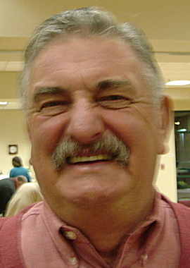

Committee Report – Church
(Presented by Dan Freeman)

Please contact Dan Freeman at 987-0908 with Church Service Program questions.

American Wheelchair Mission
(Presented by Mike Wagner)

One Week to the Kings Game!

Time is running out to get your Kings tickets for February 4th. The Kings and the Northern California Chapter of the Knights of Columbus are partnering to donate 25% of tickets sales to Knights and their family and friends to the American Wheelchair Mission. To get tickets, go to www.KofCncc.org/kings special offer code “Knights”. Hope to see you there.

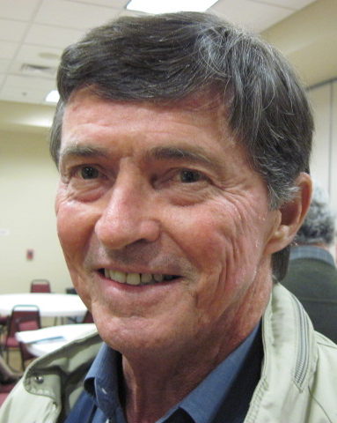

Committee Report - Community
(Presented by Tom Hogan)

Welcome to the New Year and we are certainly off to a busy start. The 2011 Knights Charity Through Golf Tournament Committee, chaired by Michael Subbotin, has been meeting on a weekly basis to plan, organize and solidify all essential aspects of this fabulous charity tournament. This Charity Through Golf Tournament will be held at Catta Verdera CC, www.cattaverdera.com located in Twelve Bridges, near Lincoln, CA, right off highway 65, on Monday, May 23rd. Please join us for this charity golf tournament that will benefit the American Wheelchair Mission, Camp ReCreation and St. Vincent de Paul Society. You will have a great day of golf at this beautiful 18-hole course. The event will include a 4 person best ball format with an 11:00 a.m. Shot Gun start. Also, this event will include a continental breakfast, box lunch, no host cocktail reception, silent auction, award dinner and many prizes. Please contact our website: www.2011kctgt.com to sign up and pay. For additional information you may call Michael Subbotin, Tel. 916-425-6347 or Michael Wagner, Tel. 916-966-6733. Ladies are invited and encouraged to play in this tournament! Awards and prizes are offered in the men’s, women’s and mixed foursomes.

An announcement similar to this will appear in the January 29th Divine Savior Church bulletin and will be published for three weeks.

This charity golf tournament is a huge endeavor and we will need a total commitment on behalf of all our Knights to make this successful. Remember to turn in your sponsorship lists to Michael Wagner.

Gentle Reminder: Please support our KofC Electronic Waste (E-Waste) Recycle and paper shredding event on Saturday, January 29th, 10:00 – 2:00 p.m. in the Divine Savior Church parking lot. Let people in your neighborhood know about this. Matt Peterson has been working hard on this project.

Please contact Tom Hogan at 988-2184 with any Community Service Program questions.

Special Thanks From The Grace Home!

You may recall that lots of important items for babies and Moms were purchased at a recent shopping trip to Costco.

Please enjoy the attached note of thanks was recently received from the Grace Home.
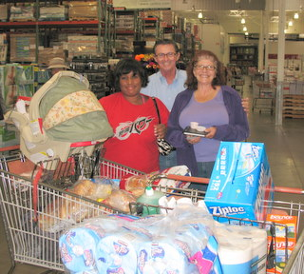
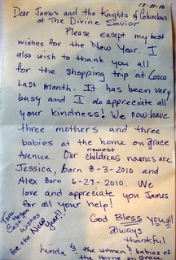

Mike Wagner and Tom Hogan (in picture) made the trip with the contacts from the Grace Home and our Council paid for the much needed items!


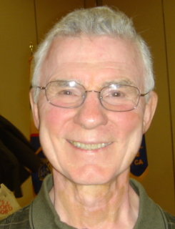
Committee Report – Culture of Life
(Presented by Mike Schaefer)

PRO-LIFE NEWS & ACTIVITIES for February 2011

Pro-Life activities in January included the annual Pro-Life Mass on Jan 21, the Walk-for-Life-West Coast in San Francisco on Jan 22, the national Walk-for-Life in Washington, DC on Jan 24, and Lobby day at the Capitol on Jan 26. They were all informative, and demonstrated the positive attitude of Pro-Life in California and the nation.

As Knights are truly a Pro-Life organization, please participate, and invite others to join you, in a P-L activity this month and every month during 2011.

A Pro-Life Mass is held monthly (2nd Tuesday @ 6:00pm) at St Philomene’s Church located at 2428 Bell Ave. The next Mass will be February 8th. Rosary starts at 5:30pm. (Call Sally @ 916-721-0378)

The Sacramento Diocese will sponsor a Pro-Life retreat for the Pro-Life community to refresh, encourage, and strengthen their activities. It will be held at the Mercy Retreat Center in Auburn on February 12th from 9:30 am to 5:00 pm. Cost is $30. (Contact Nikki Alvarez, Respect Life Coordinator, at 916-733-0140.)

An amazing Pro-Life speaker, Tony Melendez, will be in Roseville on Friday, February 18 at 7:00 pm. He was born without arms and learned to play classical guitar with his toes. His concert is a fundraiser at St Rose of Lima Catholic Church, Roseville, for young people traveling to World Youth Day in Madrid Spain. Costs are $15 for adults and $10 for all youth.

The spring Lenten 40 Days for Life will start on March 9th and last through April 16. We will focus our prayers and fasting to one of the five abortion clinics in this area. Please consider spending 2 hours/week praying the rosary in front of the clinic. Some 3500 babies were saved from abortion and 43 abortion workers were converted as well as nine abortion clinics were closed since 40 Days started 5 years ago. Mike Schaefer will have signup sheets at the Council’s business meeting.

It is still not too late to make your new year’s resolution to be more PRO-LIFE in 2011?

Any questions to the above please contact Mike Schaefer at 916/988-3171, or: mikeret_99@yahoo.com.

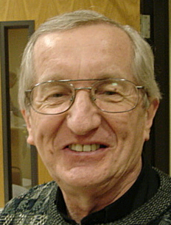
Reflections from the Chaplain
(Fr. Roman Mueller, SDS)

Dear Devoted Knights and Ladies:
For the four Sundays of February we will reflect on several parts of the fifth chapter of Matthew’s Gospel. We traditionally call this chapter the “Sermon on the Mount.” We are quite aware that other important events throughout the scriptures took place on mountains. A key event in the development of God’s people took place on Mount Sinai when Moses received the Ten Commandments.
Chapter 5 of Matthew’s Gospel takes the Ten Commandments to an entirely different level. In fact, given what is recorded in that chapter about Jesus’ teachings, we Catholics would be expected not to refer to the Ten Commandments when it comes to determining whether our behavior is up to snuff. If we live by all that Jesus says in Matthew 5, we will truly be “salt of the earth” and “the light of the world.” This is especially noteworthy because Jesus states that our light must shine before others that they may see our good deeds and glorify our heavenly Father.
Literally following the Ten Commandments might not have us fulfilling this command of Jesus. So it is wonderful that we can unite as Catholics in various ways. When we are offended by someone, how quickly can we let the love of God dissolve our anger and human inclination to get even? Some of us have over-zealous hormones when it comes to looking at and fantasizing about another’s seeming sexiness. How can we support one another in realizing that to objectify another person for our pleasure is not healthy in any way?
Living out our commitments to various relationships can often be a real challenge. While we know that some relationships must end in order to preserve God-given dignity, how can we be supportive of one another in facing our responsibilities to a relationship we have committed ourselves to?
As mentioned above, there are people that offend us. To what degree are our lives governed by the golden rule that we are to do to others what we want them to do to us? Or, upping the ante, in what ways can we make it easier for all of us to love our enemies?
Lastly, who of us doesn’t want to be comfortable and secure in this life. How can we help each other avoid allowing our possessions to possess us instead of being grateful to God for all of God’s blessings? In our world today, there is much that can cause us to feel insecure and to worry. What do we need in order to allow the goodness of God to transform our worry, anxiety and fear into a peaceful and joyful conviction that the wisdom of God will lead us through?
Fr. Roman Mueller, S.D.S.

Special Prayer Intentions

Please keep the following people in your prayers:

- Tom Larson (cancer)
- Rich Dean (chemo- cancer)
- Peter Burriesce (dialysis/foot healing)
- April Paulitz- wife of Patrick (cancer)
- Debbie McDermott- wife of Charlie McDermott (dementia)
- Julia Rapier- mother of Joe (memory)
- Bruce Wagner – brother of Bill
- Barbera Lawson (sick)
- Ladene Carvalho (sick)
- Martin Jennings (sick)
- Beverly Ridge (sick)
- Lettie Duskus (bypass surgery)
- Mike Duskus (shoulder surgery)

February / March Birthday List

Name | Birthday
Arthur Starkovich | 10-Feb
Norbert Wollak | 17-Feb
Deacon Charles Marchese Jr | 22-Feb
John Carvalho | 23-Feb
Alan Olson | 25-Feb
John Tremblay | 27-Feb
Anthony Makarczyk | 4-Mar
Robert (Bob) Reilly | 5-Mar
Edward Gaucher Sr | 7-Mar
John McAlpine | 7-Mar
Bill Braucht | 8-Mar
Thomas Maurice | 8-Mar
Tom Henderson | 9-Mar
David (Dave) Brodie | 16-Mar
Kelvin Joiner | 17-Mar
Ronald Jespersen | 18-Mar
Raymond Coughlin | 24-Mar
Richmond Dean | 24-Mar
Thomas Lawson | 26-Mar
Daniel (Dan) Tafolla | 30-Mar


Calendar of Events and Meetings
(Revised 1/30/11)

Date | Event |  | Day/Time |  | Location
Feb 1 |  | General Meeting |  | Tues 7:00 pm |  | Parish Hall
Feb 4 |  | “Knights at the Kings” |  | Friday eve |  | Arco Arena
Feb 12 |  | Strategic Plan’g Mtg |  | Sat 9:00 am |  | Parish Office
Feb 12 |  | District Free Throw |  | Sat 9:30 am |  | Holy Family
Feb 12 |  | 2nd and 3rd degree |  | All Day |  | Benicia
Feb 24 |  | Officers/Planning |  | Thurs 7:00 pm |  | Parish Hall
March
Mar 1 |  | General Meeting |  | Tues 7:00 pm |  | Parish Hall
March 9 |  | Ash Wednesday
Mar 13 |  | Corporate Communion |  | Sun 9:30 mass |  | Church
Mar 19 |  | Chapter Meeting |  | All day |  | Sacramento
Mar 26-27 |  | Membership Drive |  | All Masses |  | Church
Mar 31 |  | Officers/Planning |  | Thurs 7:00 pm |  | Parish Hall
Mar-Apr |  | 40 days for life
April
April 6 |  | General Meeting |  | Tues 7:00 pm |  | Parish Hall
April tbd |  | Information night |  |  |  | Parish Hall
April tbd |  | Social @ River Cats |  |  |  | Raley Field
April 24 |  | Easter Sunday
April 28 |  | Officers/Planning |  | Thurs 7:00 pm |  | Parish Hall
April 30 |  | 4th degree & dinner |  | All day & eve. |  | Doubletree Hotel, Sacramento
May
May 3 |  | General Meeting |  | Tues 7:00 pm |  | Parish Hall
May 7-8 |  | Mother’s Day Roses |  | All Masses |  | Church
May 12-15 |  | State Convention |  |  |  | San Diego
May 15 |  | Pancake Breakfast and Blood Drive |  | Sun morning |  | Parish Hall
May 21 |  | Pow Wow Days |  | Sat morning |  | Greenback Lane
May 23 |  | Golf Fundraiser |  | Monday |  | Catta Verdera,Lincoln
May 26 |  | Officers/Planning |  | Thurs 7:00 pm |  | Parish Hall
June
June 5 |  | Chapter Meeting |  | All day |  | St. Clare, Roseville
June 7 |  | General Meeting and election of officers |  | Tues 7:00 pm |  | Parish Hall
June 17 |  | River Cats Bus Trip
June tbd |  | Officer Installation |  | After 4:30 mass |  | Church
June tbd |  | Installation Social |  | About 6:30 |  | Parish Hall
June 30 |  | Officers/Planning |  | Thurs 7:00 |  | Parish Hall
June 28-July 4 |  | Fireworks Booth |  | Every Day |  | Cable Park
July
July 5 |  | General Meeting |  | Tues 7:00 pm |  | Parish Hall
July 28 |  | Officers/Planning |  | Thurs 7:00 pm |  | Parish Hall
August
August 2 |  | General Meeting |  | Tues 7:00 pm |  | Parish Hall
August 25 |  | Officers/Planning |  | Thurs 7:00 pm |  | Parish Hall
September
Sept 6 |  | General Meeting |  | Tues 7:00 pm |  | Parish Hall
Sept 18 |  | Pancake Breakfast and Blood Drive |  | Sun morning |  | Parish Hall
Sept 29 |  | Officers/Planning |  | Thurs 7:00 pm |  | Parish Hall
October
Oct 4 |  | General Meeting |  | Tues 7:00 pm |  | Parish Hall
Oct 27 |  | Officers/Planning |  | Thurs 7:00 pm |  | Parish Hall
November
Nov 1 |  | General Meeting |  | Tues 7:00 pm |  | Parish Hall
Nov 17 |  | Officers/Planning |  | Thurs 7:00 pm |  | Parish Hall
November 24 |  | Thanksgiving
December
Dec 6 |  | General Meeting |  | Tues 7:00 pm |  | Parish Hall
Dec 29 |  | Officers/Planning |  | Thurs 7:00 pm |  | Parish Hall

